Overdale Community Primary School – Nursery Spring term 1 2024
Theme: Another world
Specific Area: Literacy  Talk for writing texts: Fiction- The Enormous Turnip Non-fiction- Turnip Soup  Focus Texts: Each, Peach, Pear, Plum/ Hairy Mclary  We will be continuing our Little Wandle ‘Foundations for Phonics’ programme by learning the sounds: m, d, g, o, c, k, e. We will be sending these sounds home weekly for you to practise at home.  We are continuing to support the children with their name recognition as well as providing opportunities for them to practise ordering the letters in their name. We are also practising name writing weekly for those children who are ready to do so.  We will be continuing to use Talk for Writing to develop our story telling and to create our own stories. This half term we are focusing on the characters in the story. We will first explore the characters in the traditional tale and then will move onto ‘innovating’ the story by introducing our own characters.  We will also be learning and exploring a variety of nursery rhymes and stories focusing on specific vocabulary to support the children’s developing speech and understanding. This half-term our daily story time will be a selection of non-fiction and fiction books focusing on space. We will be sharing these on Class Dojo each week |  | Specific Area: Mathematics  Comparison  We will be exploring how to compare quantities of objects by placing them in lines.  Cardinality (Counting/ subitising)  We will be focusing on the concept of ‘2’. We will explore 2 by learning different ways to make 2, finding pairs, learning counting rhymes involving 2, subitising 2 (looking at a group of objects and realise how many you see without counting). We will be sharing these activities on class Dojo  Shape, space, measures  We will be using our space theme to investigate length. We will be making comparisons between the length of various objects including rockets as well as exploring length related to time- How long could it take to fly to the moon?  We will also be exploring routs and locations by looking at maps and considering language such as in front/ behind etc.  Pattern  We will continue to build on our understanding of pattern by recognising AB patterns involving colour. We will also be challenging the children to continue an AB pattern.
Specific Area: Knowledge and Understanding of the World  We will be focusing on materials, forces and how things work this half-term as well as introducing occupations through our space theme.  We will be learning how to describe a variety of materials and exploring how they are similar and different. We will consolidate our learning by choosing the best materials to build our own spaceship.  We will be exploring Winter and the changes which happen at this time. We will also be considering ways to support wildlife during winter.  As part of our learning about space, we will also be following the phases of the moon which will support us with our celebration of Chinese New Year at the end of this half term. | Another world  BIG QUESTION  What would it be like to visit the moon? |  | Prime Area: Personal and Social Development (PSED)  Each half-term we focus on an aspect of our school values. This half-term we will be exploring ‘resilience’  We will be taking part in activities which focus on persistence, developing confidence and solving problems. We will also be learning how to work together to overcome challenges by taking part in team building exercises as well as learning different coping strategies for when things don’t go our way.  With the winter weather upon us we will also be having a focus on supporting the children to fasten their coats by themselves. Please support us at home by encouraging and modelling.
Prime Area: Physical Development  The children will be continuing to develop their finger strength with a variety of fine motor activities. This is in order to support their pencil grip for mark making and name writing. We are now encouraging children who are ready to use a tripod grip when mark making. We will be sending home an information sheet about pencil grip in the first week.  Outside the children will be practising the gross motor skills by taking part in hopscotch, balancing, climbing activities. They will also be learning a range of target games. | Prime Area: Communication and  Language  The children will be very familiar with our concept cat now, who supports us to learn key concept vocabulary. The children will be introduced to a key word each week which we will explore in a variety of concepts. These will also be shared on class Dojo with activities to support with at home.  We will be focusing on counting nursery rhymes this half-term as well as revisiting the rhymes we have previously learnt.  We also have a bank of vocabulary which we are learning alongside our focus and Talk for Writing texts. These will be shared as we learn them. |  | Specific Area: Expressive Arts and Design Music  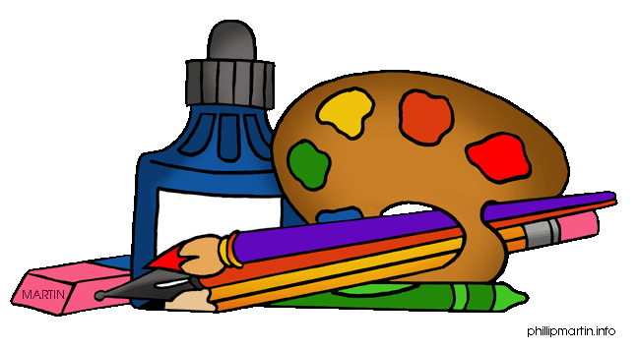  This half term will be investigating the sounds we can hear in space as well as exploring how to move like a rocket.  We will also be focusing on model making and how to improve our creations. Support us at home by discussing the models your child make e.g. duplo, junk modelling and exploring together how these can be improved e.g. by adding features such as doors, windows etc.  At the end of the half-term we will be creating our own Chinese lanterns. We will also be tasting a variety of foods which would be part of the Chinese New Year celebrations.

Reading – We will be sending children home with a story from our ‘borrow box’ this half-term. We want foster a love of reading in our children so they will be selecting their own book to bring home and share with you. Please read and discuss this with your child at home and write a comment in your child’s reading record. We would like you to share any story with your child at least 3 times a week and record this in their reading record each time. Books will be changed once a week, but your child’s book bag needs to be in school every day please – thank you for your support
Dojo profiles – Please remember to send us photos and videos of what your child is doing at home – anything from walking the dog, swimming, playing in the play park, baking etc – we can’t wait to see your photos

